**HMS Track Shoe Report**

**Track Parents**,

As you are aware, track is an inexpensive sport compared to other sports, however, your young athlete will need a **good pair of running shoes**. **All running shoes are not the same**. Try not to purchase running shoes at department stores. Stores such as **Running Lab, Nike**, or **Adidas** outlet stores will be of great help in purchasing running shoes. If you have concerns with your child’s foot, or if your child has lower body pain when they run, **Runnin’Gear** in Brighton may be able to help by custom fitting a shoe for your child. **Running Lab** has cutting edge high speed camera fit process. An observed treadmill run, and measurement with excellent customer service. Running Lab offers 10% off for shoes or spikes, or 15% off both and running classes are offered. **Runnin’ Gear** will also personally fit a shoe to your child and offer 10% off shoes and 20% off spikes.

Nike Lunar Fly

* $90

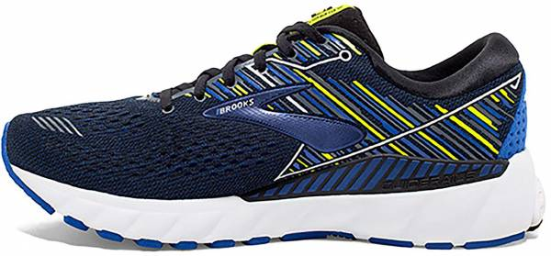**Listed here are locations of stores and price point suggestions for a few very good running shoes.**

* **Running Lab**

328 W.Main Street

Brighton ,MI 48116

Web: www.runninglabstore.com

Phone: 810-225-9123

Brookes Adrenaline 23

* $140

Owner: Ken Larscheid

Store Manager: Tony Reese

* + **Cutting edge high speed camera fit process.**
  + **Treadmill run and measurement with excellent customer service.**
  + 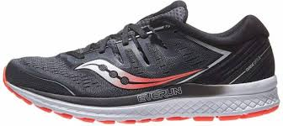**10% off for shoes or spikes, or 15% off both.**
  + **Good Form Running classes offered.**
  + **Clearance items possible**

Saucony Guide 16

* $140
* **Nike Outlet Stores**

Tanger Outlet Mall

1475 N Burkhart Rd. Howell, MI

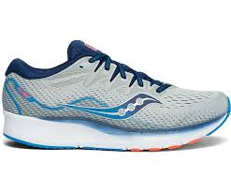Phone: 517- 552-6453

* **Adidas Outlet Stores**

Saucony Ride 16

* $140

Tanger Outlet Mall

1475 N Burkhart Rd.

Howell, MI

Phone: (517) 552-3337

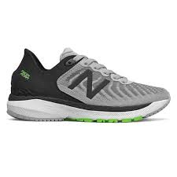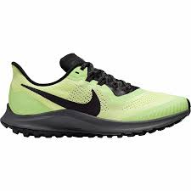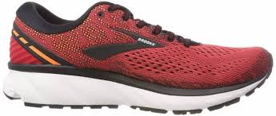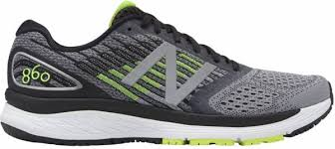

New Balance 860-V13

* $140

New Balance 880-V13

* $140

Nike Pegasus 40

* $140

Brookes Ghost 15

* $140